**Mini Game Design Doc Template**

To create your own copy, go to “File” → “Make a Copy” (or click [here](https://docs.google.com/document/d/1nJYx6wZ97PiVaGdpQrPgEBnAV_ZTvYatdIjRbCWhIHQ/copy)).

Forked and modified from: [Game Dev Underground](https://docs.google.com/document/d/1npEvqcMZSp0IX2hWw6Qq0WqJVfmVqS_YOGFWnnwfh-A/edit) & [Josehzz](https://gdu.io/dev/josehzz) (under [CC 4.0](https://creativecommons.org/licenses/by/4.0/))

Additional game design resources [here](https://github.com/mikewesthad/Game-Design-Document-Resources).

**Mantra/Tagline**

A single sentence description of the game that you will use to guide design decisions. *Example: an educational infinite running game that tests your mental reflexes.*

|  |
| --- |
| An infinite arcade action shooter, in which the player must test their hand/eye coordination and their reflexes. |

**Design Pillars**

List up to 3 words/phrases that convey the feeling or emotion you want the player to experience. *Example: Fast. Cerebral. Smart.*

|  |  |  |
| --- | --- | --- |
| Fast | Intense | Engaged |

**Story/Gameplay Summary**

List what the game is from a gameplay and/or story perspective. *Example: This game places the player into an infinite runner where they have to answer progressively harder trivia questions about geography in order to get power ups and stay alive.*

|  |
| --- |
| The game is an arcade, top-down shooter in which the player must survive against unending waves of enemies that increase in speed and number. The player has a weapon with infinite ammo and must use their reflexes combined with powerups to survive for as long as possible. |

**Storyboard**

What’s the arc of the gameplay? See this [introduction to storyboards](https://www.nngroup.com/articles/storyboards-visualize-ideas/) for user experience design. Use their [template](https://media.nngroup.com/media/articles/attachments/Storyboard-Template.pdf), or something like it with frames that have captions. See some game storyboard examples: [VR game](https://www.artstation.com/artwork/nxzXr), [robo game](https://sites.google.com/site/videogamedesigntsanh/home/storyboard), [platforming game](https://www.storyboardthat.com/storyboards/soradora/storyboard--penguin-jump). Your storyboard should have at least six frames that explain the key features of your game. Think about the progression all the way from title screen to the win/end screen.

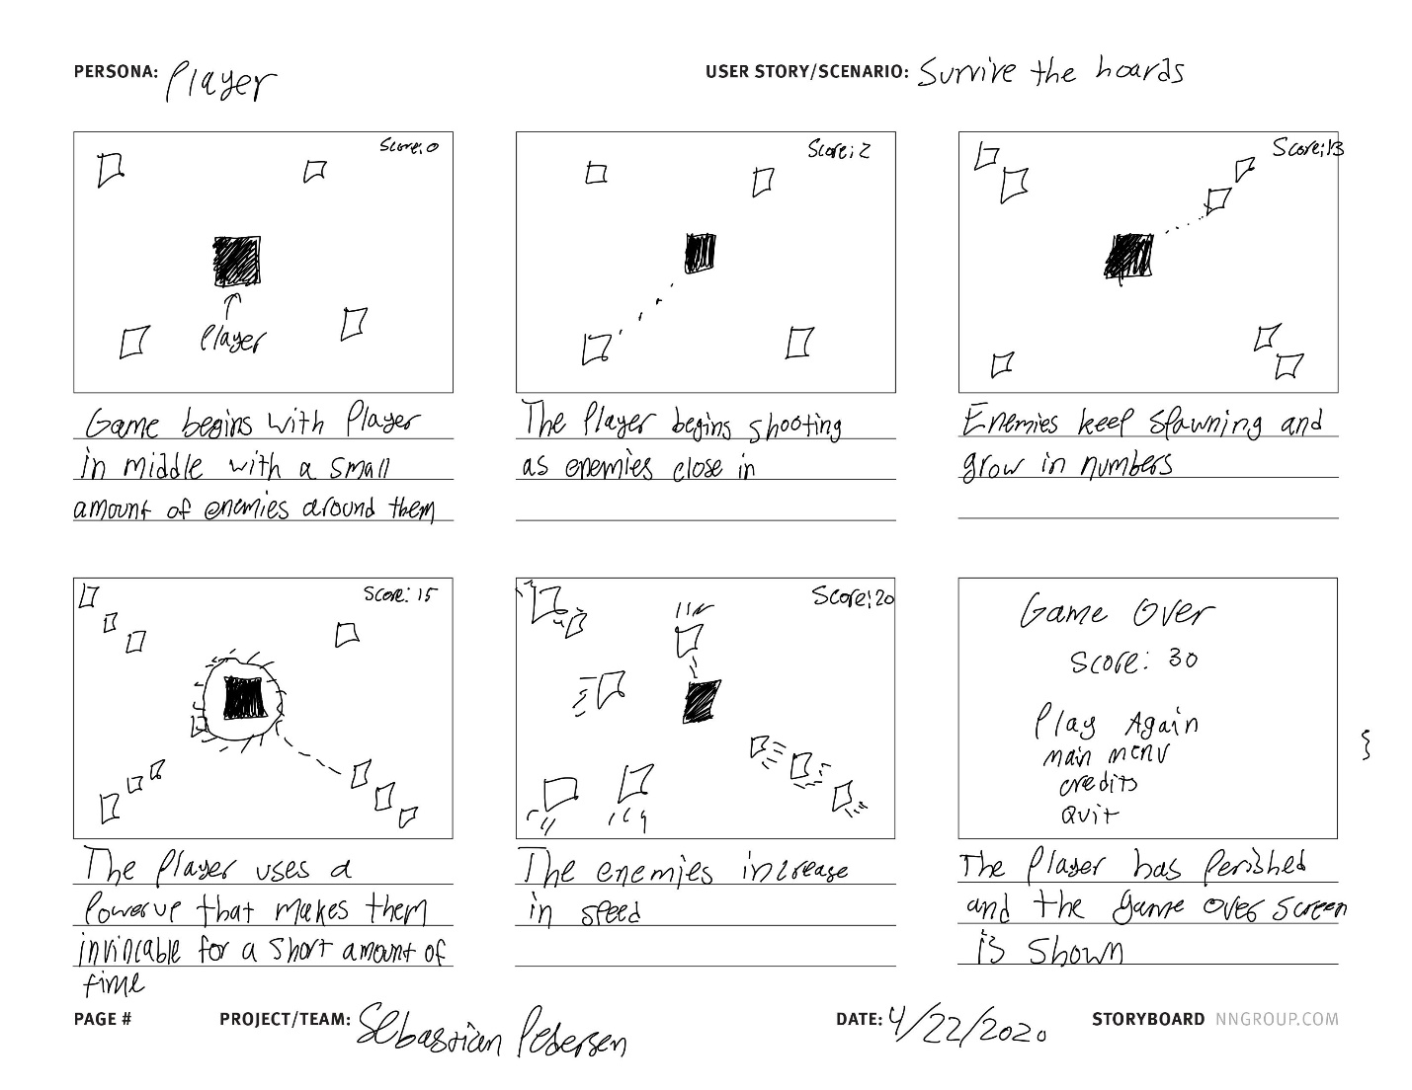

**Feature List**

List all the features that you want to include in your game. Don’t worry about implementation - it’s okay to list a feature you don’t know how to make. Everything is a feature - from collectables, to player controls to showing visual feedback when a character is hit, to story voice-overs triggered when you enter a room, to a HUD, to the player’s footstep sounds, etc. If you’ve got less than six features, you are very likely missing things or your features are too big (e.g. “platforming” is not a feature, it’s multiple - player movement controller, level design, player animation, etc.).

|  |  |
| --- | --- |
| * Score/Timer (Expected time: 30 min) * Enemies follow player (Expected time: 1 hour; Actual time: 1 hour) * Shooting (Expected time: 2 hours; Actual time: 2 hours) * Enemies increasing speed (Expected time: 45 min; Actual time: 30 min) * Start menu (Expected time: 15 min; Actual time 15 min) * Game Over menu (Expected time: 15 min; Actual time 15 min) | * Player movement controller (Expected time: 45 min; Actual time: 30 min) * Enemy spawn (Expected time: 1 hour; Actual time: 1 hour) * Game Music (Expected time: 45 min; Actual time: 45 min) * Super Strength Powerup (Expected time: 1 hour; Actual time: 1 hour) * Tutorial menu (Expected time: 15 min; Actual time 15 min) * Credits menu (Expected time: 15 min; Actual time 15 min) |

**Prototype**

Describe what you’ll need to build for your prototype of the core mechanic of your game. What’s the least you can build to test your idea? *For the infinite runner quiz game, that would mean that, at the bare minimum, my prototype should feature a player object moving forward with obstacles spawning in the way and a way to track when the player hits an obstacle. I would use simple Unity primitives for the player (gray sphere) and obstacles (red boxes).*

|  |
| --- |
| At the very least, I need a player and enemy movement controller, an infinite enemy-spawner, and collision detection. |

**References**

Link to at least three links to other pieces of media - books, designs, other games, etc. - that have something similar to what you are trying to accomplish and explain which element you are interested in. It could have similar gameplay elements, a related story motif or an aesthetic you want to remix.

|  |
| --- |
| <https://stardewvalleywiki.com/Journey_of_the_Prairie_King>  <http://www.freeasteroids.org/welcome/>  <https://store.steampowered.com/app/1262770/Snake_Core/> |

**Target Audience & Platform**

Who is the target audience for the game (e.g. age, interests, type of games they play, when they play)? How does that experience it (e.g. mobile, browser, AR/VR, desktop with keyboard, console with controller site-specific, etc.)? “Everybody” is not a target audience. *For example, for an educational game to teach geography, the target audience might be high schoolers who like to play quick and rewarding casual games, and it will be played in classrooms on PCs with a mouse and keyboard.*

|  |
| --- |
| Target audience are people who enjoy arcade games that have a fast pace and a sense of intensity. This would be a desktop and/or browser game that uses the keyboard and possibly the mouse. |

**Asset Research**

This is primarily a scripting class, so the focus is not on creating your own assets. Look through the free resources to find assets that you are considering for your project. Link them below. At minimum, you should have both visual assets and sound assets linked below.

|  |
| --- |
| <https://assetstore.unity.com/packages/3d/characters/humanoids/zombie-30232>  <https://assetstore.unity.com/packages/3d/environments/landscapes/rpg-poly-pack-lite-148410>  <https://assetstore.unity.com/packages/audio/music/loop-music-free-111896>  <https://assetstore.unity.com/packages/audio/sound-fx/weapons/futuristic-gun-soundfx-100851> |